NUCLEAR DETECTION SENSOR

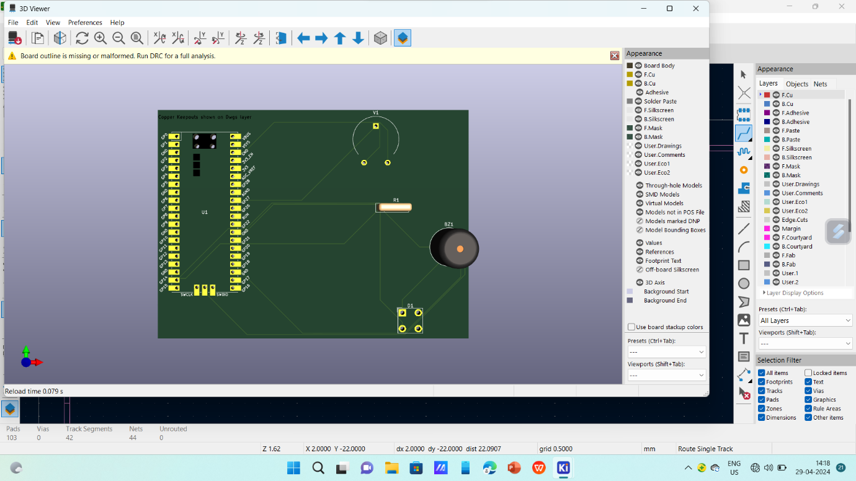

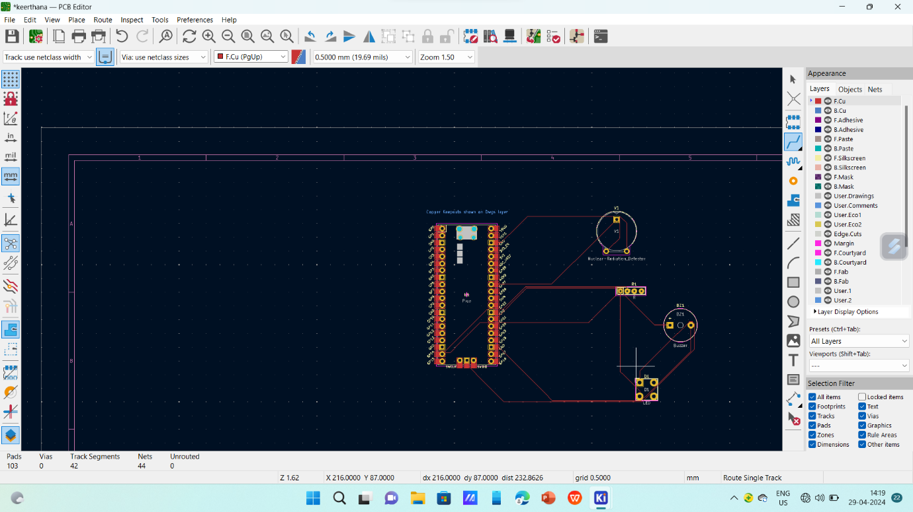

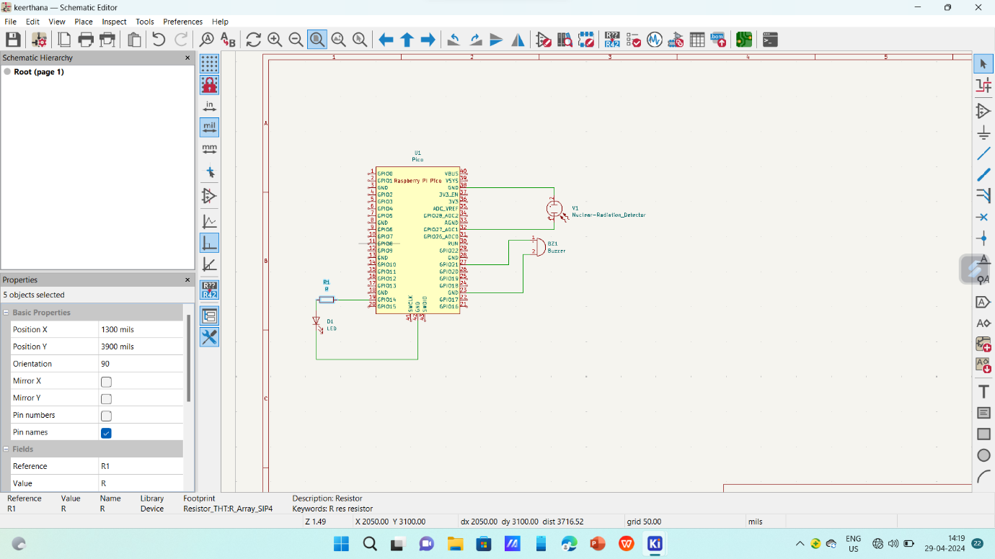

Project by:

1.G.Keerthana (21781A0472)

2.G.Deepthi (21781A0467)